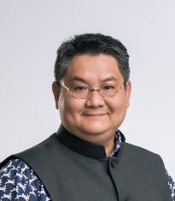
Associate Professor Piti Srisangnam, PhD

Executive Director of the ASEAN Foundation

Assistant Professor of Economics,
Faculty of Economics, Chulalongkorn University

2021 Dongfang Scholars. Peking University. China.

Dr. Piti Srisangnam holds a Ph.D. degree in Economics and Commerce from the University of Melbourne (Australia), and an M.A. degree in International Economics and Finance from Chulalongkorn University (Thailand). He has been teaching International Economics and ASEAN Studies for bachelor and master degree students at Chulalongkorn University since 2002.

He has been Deputy Director for Academic Affairs of the Centre for European Studies from 2010 to 2012 and Deputy Director for Academic Affairs of the ASEAN Studies Center in 2012, both at Chulalongkorn University, before he became Director of the Center in 2013.

He has been selected for the 2019 Rising Star Royal Thai Government Scholarships Association Award: Rising Star. In 2021, he was granted the Dongfang Scholarships to become a visiting scholar at Peking University for 1 semester. In 2023, He received the Australian Alumni of the Year award from the Australian Alumni Association of Thailand and Australian Embassy, Thailand.

He has published several papers in journals and books e.g. on the economic development in Southeast Asia, on trade in services among ASEAN member states, on regional economic integration of ASEAN and of the European Union, on the economic reform and SME development in Thailand, on ASEAN-India, ASEAN-China and ASEAN-Japan and ASEAN-ROK relations. Apart from academic works, he also hosts 4 radio programs related to current issues in ASEAN.

